07-10-2021

ABHINAV RANJAN

RA1911003010003

CSE A1 SECTION

SRMIST , KTR

CN LAB EXP 12 - NAT TRANSLATION

1. MAIN PAGE - CISCO PACKET TRACER

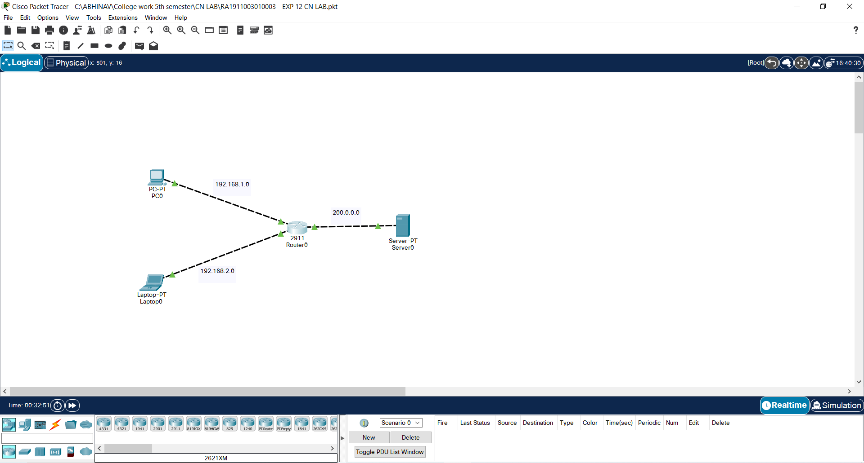

1. Pc 0 pinging laptop 0 and serverPT

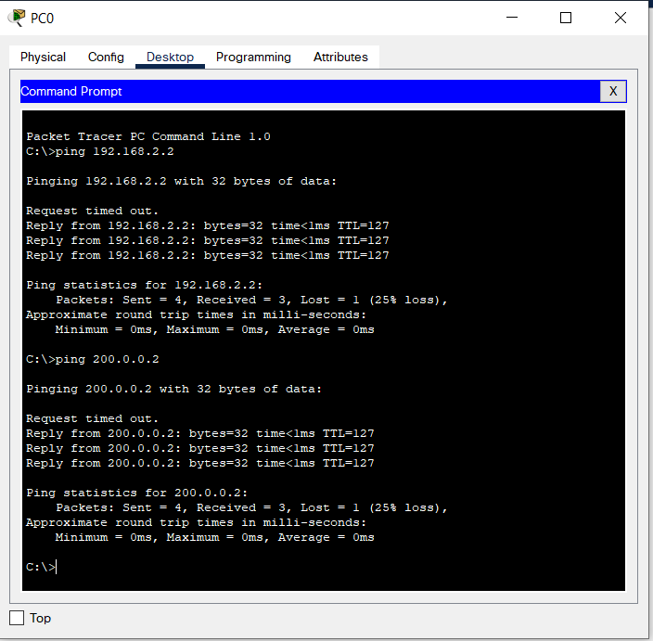

1. Router0 CLI

